Exp No:1 Title of the Exercise: Operating system Installation, Basic Linux commands

Date:24/08/2022

Aim: Installation of OS and Practice of basic Unix Shell Commands

Procedure: INSTALLATION OF:

1. VMware Player

To download VMware Player:

* Navigate to the VMware Download Center.
* Locate VMware Player under Desktop & End user Computing.
* Select the installer from the list according to our host operating system.
* Click Download.
* If prompted, log in to our Customer Connect profile. If we do not have a profile, create one. For more information, see How to create a Customer Connect profile (2007005)
* Ensure that our profile is complete and enter all mandatory fields.
* Review the End User License Agreement and click Yes if we agree.

If the installer fails to download during the download process:

* Delete the cache in our web browser.
* Disable the pop-up blocker in our web browser.
* Microsoft Internet Explorer: How to turn Internet Explorer Pop-up Blocker on or off on a Windows XP SP2-based computer
* Try to download using a different web browser application.
* Disable any local firewall software.
* Restart our machine.
* Download the installer from a different computer or network.

To install VMware Player on a

1. Windows Host:

* Log in to the Windows host.
* Open the folder where the VMware Player installer was downloaded. The default location is the Downloads folder for the user account on the Windows host.
* Right-click the installer and click Run as Administrator.
* Follow the on-screen instructions to finish the installation.
* Restart the host machine.

After Installation:

* The installer creates a desktop shortcut, a quick launch shortcut, or a combination of these options in addition to a Start Menu item.
* To start VMware Player on a Windows host system, select Start > Programs > VMware Player.

1. Linus Host:

* Log in to the Linux host with the user account information that is to be used in the VMware software.
* Open the terminal Interface.
* Change to root.
* Change the directories to the directory that contains the VMware Player bundle installer file. The default location is the download directory for the user.
* Run the appropriate player installer file for the host system.

There are a few command line operations available:

* --gtk

Opens the GUI-based VMware installer, which is the default option.

* --console

Use the terminal for installation.

* --custom
* Use this option to customize the locations of the installation directories and set the hard limit for the number of open file descriptors.
* --regular

Shows installation questions that have not been answered before or are required. This is the default option.

* --ignore-errors or -I
* Allows the installation to continue even if there is an error in one of the installer scripts. Because the section that has an error does not complete, the component might not be properly configured.
* --required

Shows the license agreement only and then proceeds to install Player.

* Accept the license agreement.
* Follow the on-screen instructions or prompts to finish the installation.
* Restart the Linux host.

After Installation

* VMware Player can be started from the command line on all Linux distributions.
* On some Linux distributions, VMware Player can be started in the GUI from the System Tools menu under Applications.
* To start VMware Player on a Linux host system from the command line, run the vmplayer command in a terminal window

2.WINDOWS

Step 1 - Format the drive and set the primary partition as active

1. Connect the USB flash drive to our other PC.
2. Open Disk Management: Right-click on Start and choose Disk Management.
3. Format the partition: Right-click the USB drive partition and choose Format. Select the FAT32 file system to be able to boot either BIOS-based or UEFI-based PCs.
4. Set the partition as active: Right-click the USB drive partition and click Mark Partition as Active.

Step 2 - Copy Windows Setup to the USB flash drive

1. Use File Explorer to copy and paste the entire contents of the Windows product DVD or ISO to the USB flash drive.
2. Optional: add an unattended file to automate the installation process. For more information, see Automate Windows Setup.

Step 3 - Install Windows to the new PC

1. Connect the USB flash drive to a new PC.
2. Turn on the PC and press the key that opens the boot-device selection menu for the computer, such as the Esc/F10/F12 keys. Select the option that boots the PC from the USB flash drive.

Windows Setup starts. Follow the instructions to install Windows.

1. Remove the USB flash drive.

3.Linux

* Download .iso or the ISO files on a computer from the internet and store it in the CD-ROM or USB stick after making it bootable.
* We need to restart our computer after attaching pen drive into the computer. Press enter at the time of boot, here select the pen drive option to start the further boot process. Try for a manual boot setting by holding F12 key to start the boot process. This will allow we to select from various boot options before starting the system.
* Set the keyboard lawet.
* Now we will be asked What apps would we like to install to start with Linux? The two options are ‘Normal installation’ and ‘Minimal installation’.
* Select the drive for installation of OS to be completed. Select “Erase Disk and install Ubuntu” in case we want to replace the existing OS otherwise select “Something else” option and click INSTALL NOW
* A small panel will ask for confirmation. Click Continue in case we don’t want to change any information provided. Select our location on the map and install Linux.
* Provide the login details.
* After the installation is complete we will see a prompt to restart the computer

3.Dual OS

Dual operating systems can be downloaded in many different ways. Some of those

ways are as follows :

* Use linux in windows as a virtual machine : This runs a Linux OS like any other

application within Windows. This is also one of the safest ways to get a feel of Linux.

* However, this will utilize our system resources and if we have less than 4Gb of

RAM, I won’t advise using it extensively.

* Use a live version of Linux: In this method, we put Linux on a USB or DVD and we

boot from it. This is usually slow and our changes done to the Linux system are

(normally) not saved. This is particularly useful if we just want to see what Linux

feels like.

* Remove Windows and Linux: If we have backed up our data and have a recovery or

installation disk of Windows ready with we or if we are determined that we are not

going back to Windows, we can remove Windows completely and use only Linux.

* Install Linux alongside Windows: This method is called dual booting Linux with

Windows. Here, we install Linux on a system that already has Windows. And when

our system powers up, we can choose if we want to use Windows or Linux. This

involves touching the disk partition and sometimes boot order. Absolute beginners

often find it complicated but this is the best way to use Linux and Windows together

in one system. And in this article, we’ll see how to dual boot Linux Mint with

Windows 10.

The steps that are to be followed for downloading linux as the second operating

system are as follows:

1. Create a live USB or disk:

A live USB is a portable USB-attached external data storage device containing

a full operating system that can be booted from. The term is reminiscent of

USB flash drives but may encompass an external hard disk drive or solid-state

drive, though they may be referred to as "live HDD" and "live SSD"

respectively.

2.Make a new partition for the Linux meet:

In the windows system go to the start menu and click partition then a disk management utility is shown. Open the Disk Management System. In this disk

management system carefully select the disk from which we should shrink

the volume to create the required space for our required partition.

3. Boot in to live USB:

Plug the live USB or disk into the computer and restart the computer. While

booting the computer press F10 or F12 function key (defers from computer to

computer) to go to the boot menu. Now, choose the option to boot from USB or

Removable Media.

4. Start the installation:

This step might take some time for completion. The first thing asked is the

language in which this will operate. Then it does a few checks on the available

space, battery and internet connection.

5. Prepare the partition:

The most important aspect in downloading the dual os is where the files are to

be stored. The application gives a few options on where to store the files. The

options given are as follows:

The last option should be selected.

6. Create root, swap and home:

Create a root partition. Choose the available free space and then press +

The next part is to create a swap partition. The next query is regarding the swap size that should be put. This depends on the available RAM size, the user needs, available disk space and whether the user uses hibernation or not. The suggested swap size for RAM available is as follows:

RAM less than 2 GB: Swap should be double the size of RAM

RAM between 2 to 4 GB: Swap should be RAM size + 2 GB

RAM between 6 GB to 8 GB: Swap should be size of RAM

RAM more than 8 GB: Swap should be half the size of RAM or less

The next step is to create Home. Try to allocate the maximum space available for home because this is where the files will be stored and saved.

7.Then click on the install now button.

8.Complete the rest of the process.

9.After completing the rest of the process restart the system

10.Dual Operating systems have been installed in the systems and can be used at any required time.

4. Linux in VMware:

. There are a few prerequisites that need to be followed to install Ubuntu on VMware. The

requirements to do so are as follows:

1. A host system with minimum conditions of:

1. 8GB of memory

2. A Quad core CPU

3. 500 GB of hard disk space

2. VMware Workstation Pro or Player Application:

3. Ubuntu Operating system to install on VMware Workstation

The steps to download linux in VMware is as follows:

1. Fire up VMWare Workstation

Download the VMWare Workstation application for our host operating system and install it on our machine. The installation procedure is pretty simple and straight. Read the documentation for more details. Open the app after installation. Create a new Virtual Machine.  
  
  
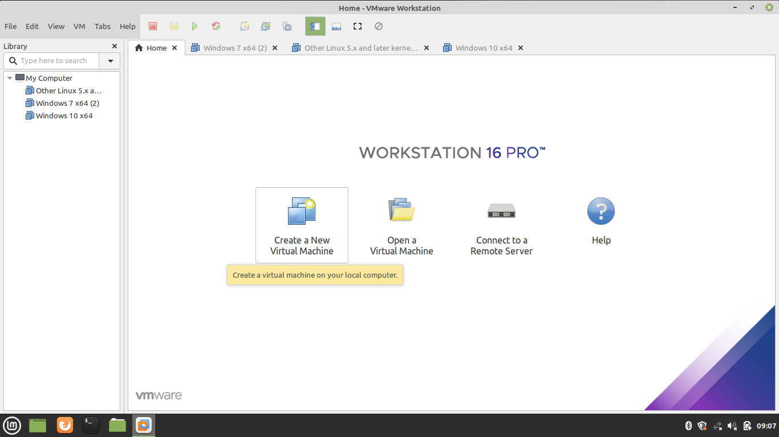

1. Select Custom Configuration Wizard

We can choose either Typical or Custom Wizard. We recommend selecting Custom if we want to install with all the configurations. If we are okay with default configurations then go ahead with Typical configurations.  
  
  
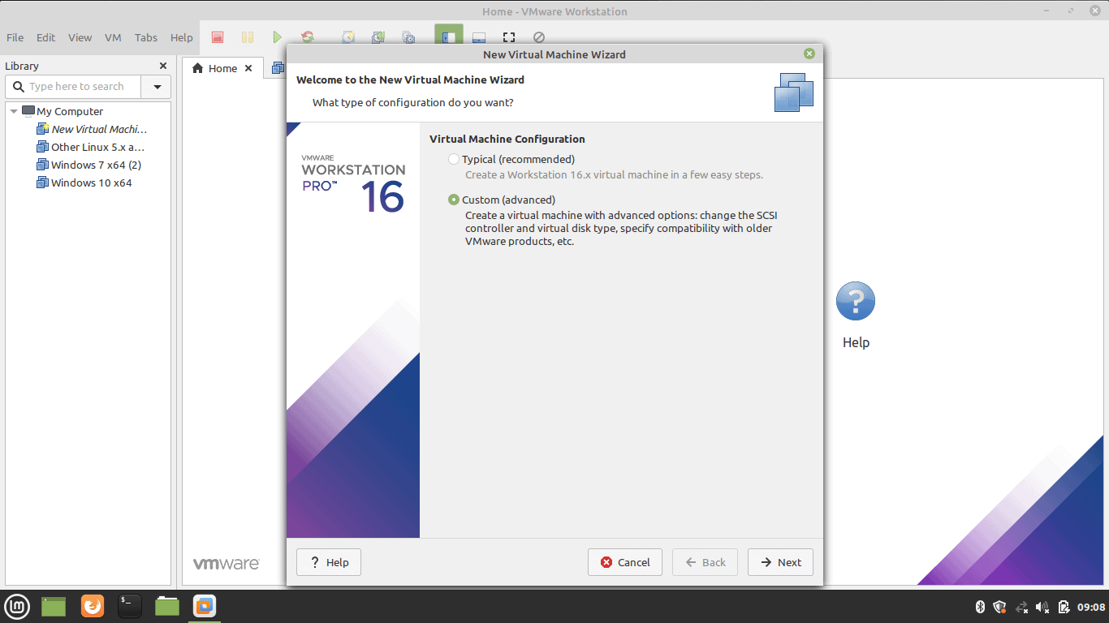

1. Select Virtual Machine Hardware Compatibility

Go with the default option if we don’t have the choice.  
  
  
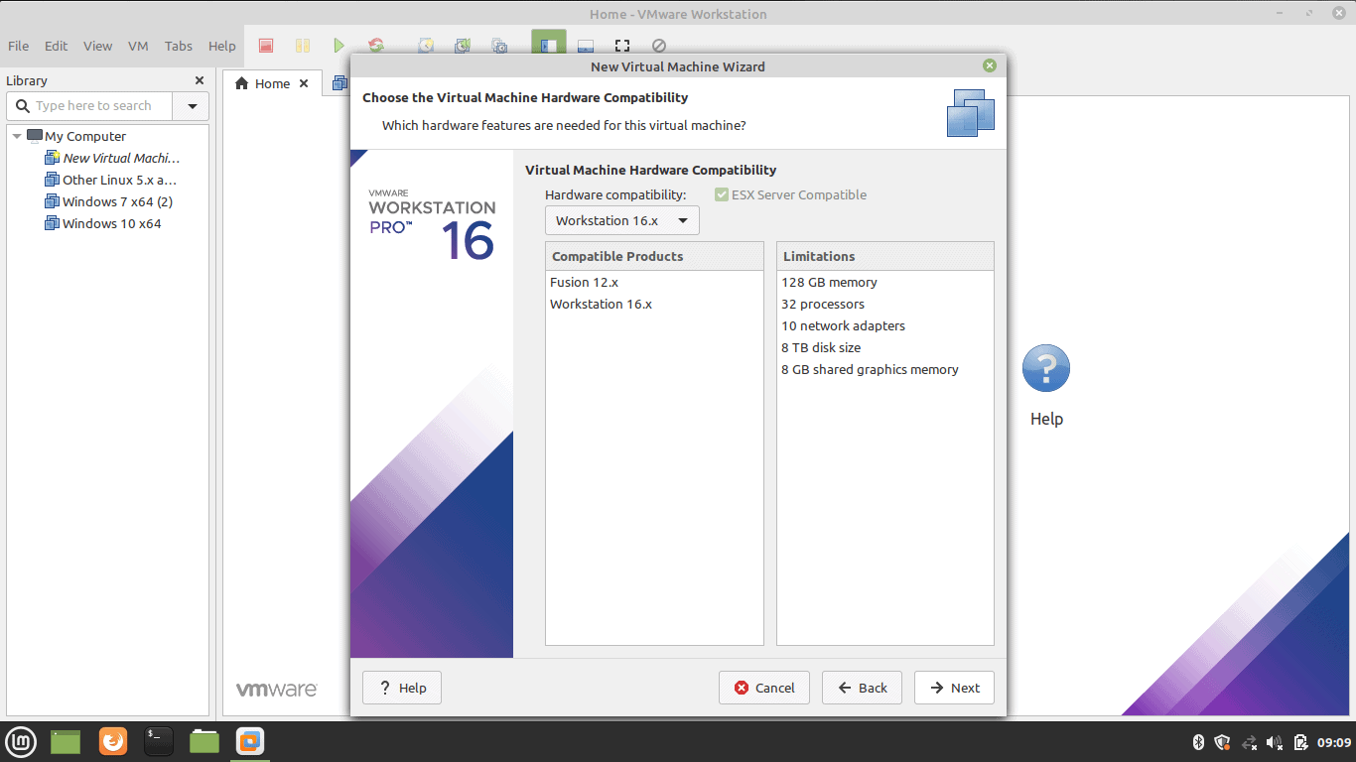

1. Select the Operating System Media

Select ‘I will install the operating system later’ for an interactive installation.  
  
  
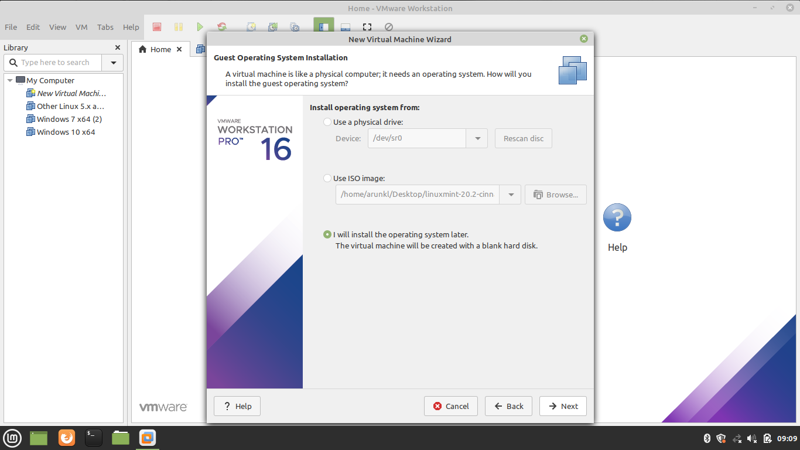

1. Select Guest Operating System

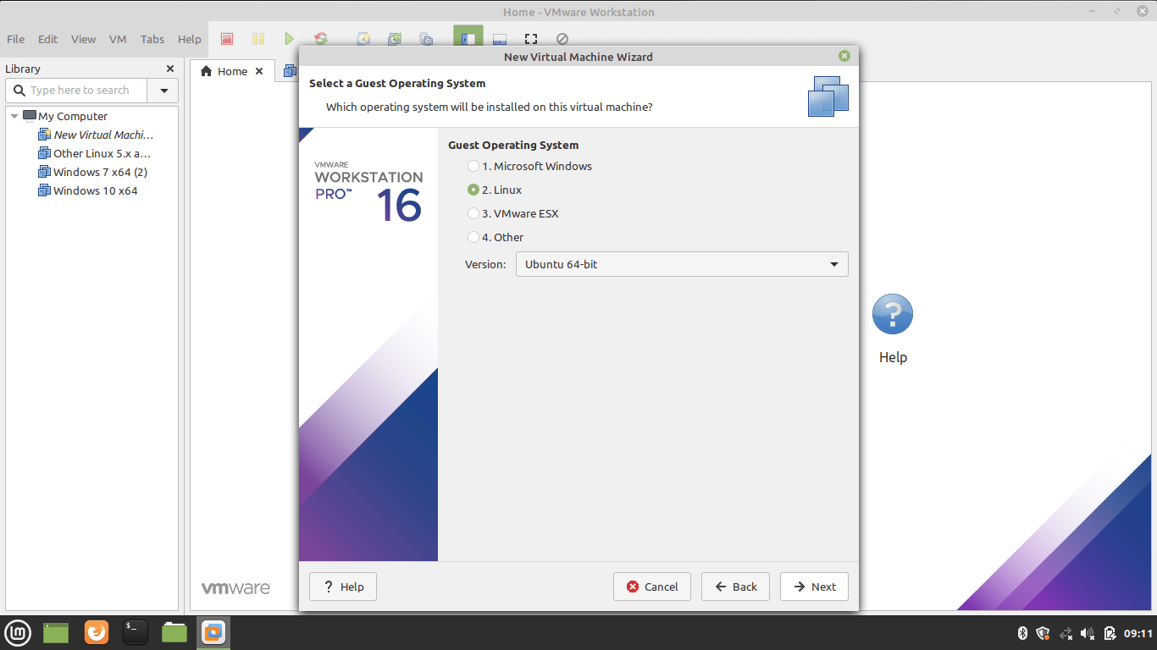

1. Name the Virtual Machine Name and location

Type a name and give the location details.  
  
  
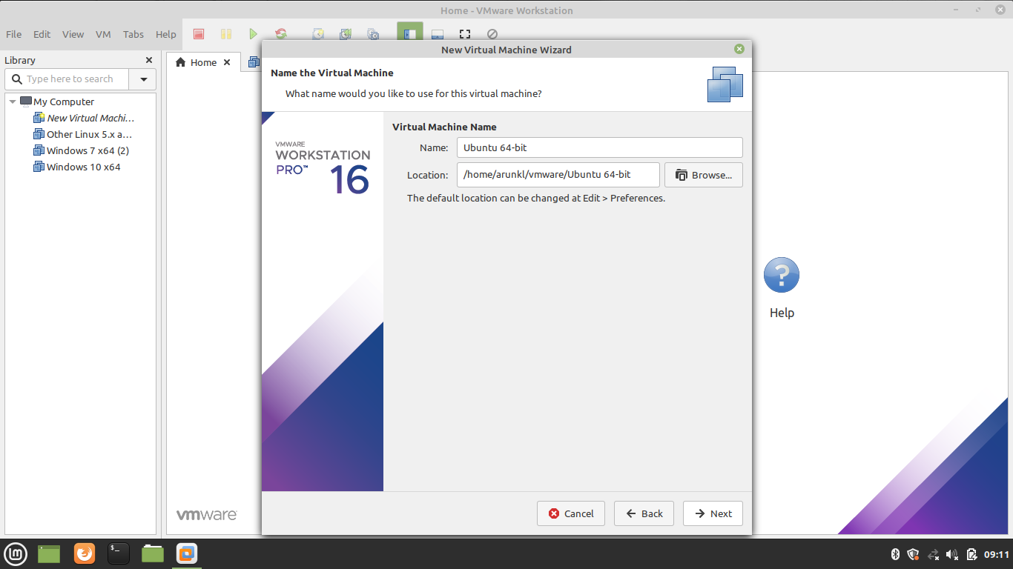

1. Allocate the Processors

Assign the processors, Calculate the processor required to run the host machine. Assign the leftover resources to the virtual machine.  
  
  
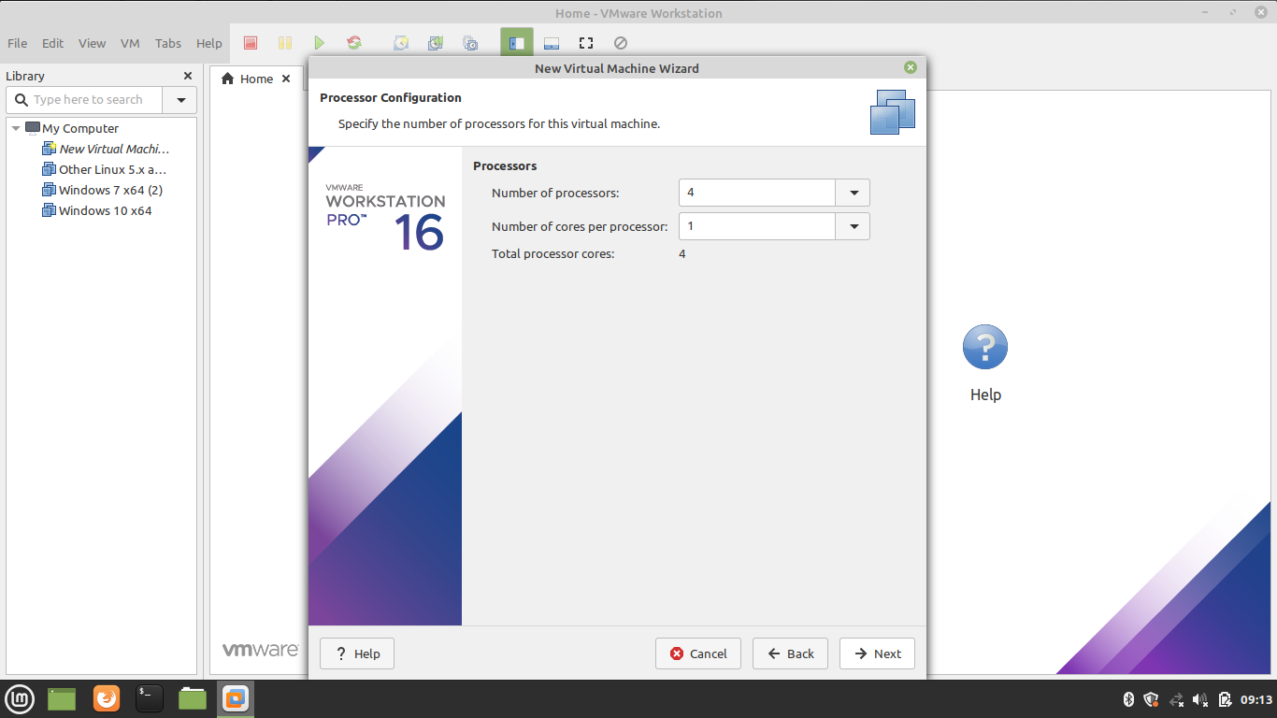

1. Allocate the Memory for Virtual Machine

Memory allocation calculation is the same as the processor allocation. Leave sufficient memory for the host system and allocate the remaining memory for the virtual machine.  
  
  
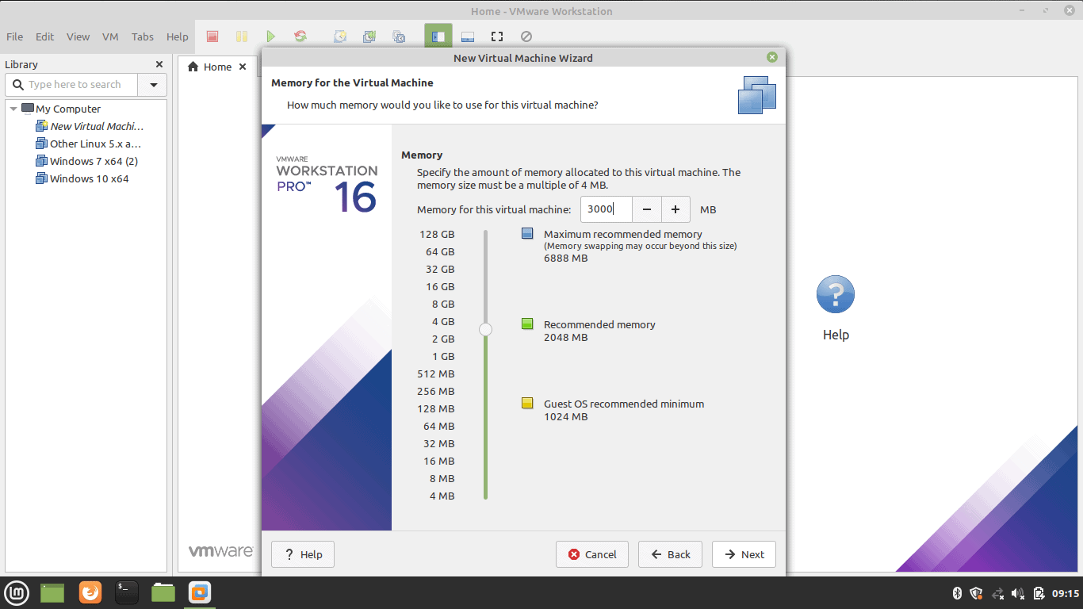

1. Choose the Network Configuration

Select any one of the network configurations as per our requirement.  
  
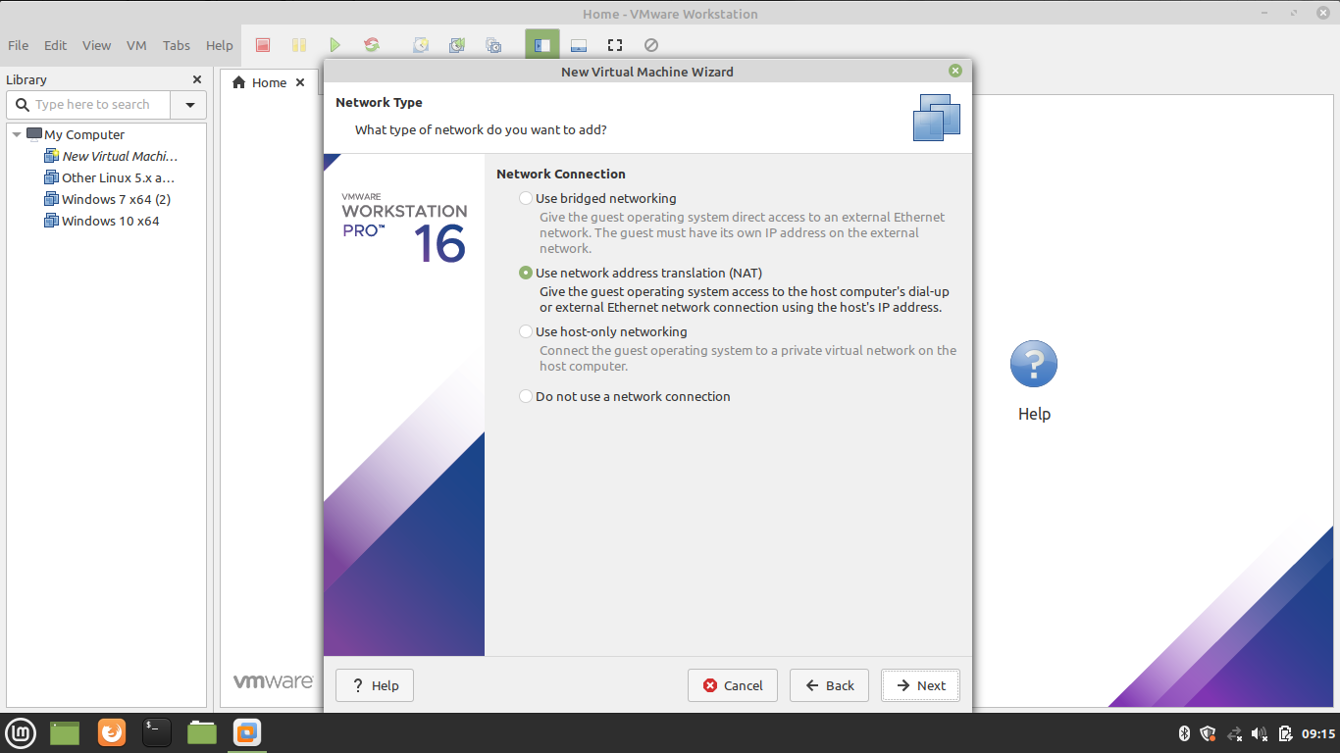

1. Select the I/O Controller Type

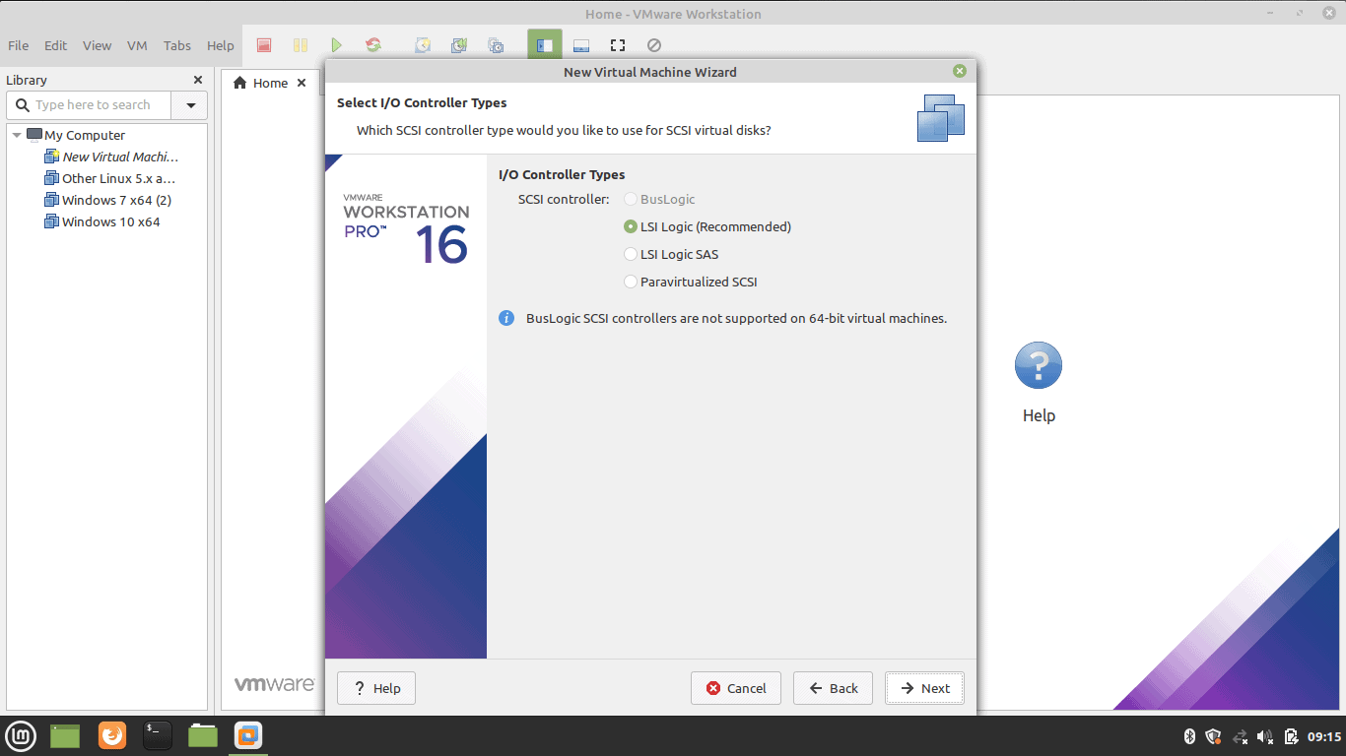

1. Select Disk Type

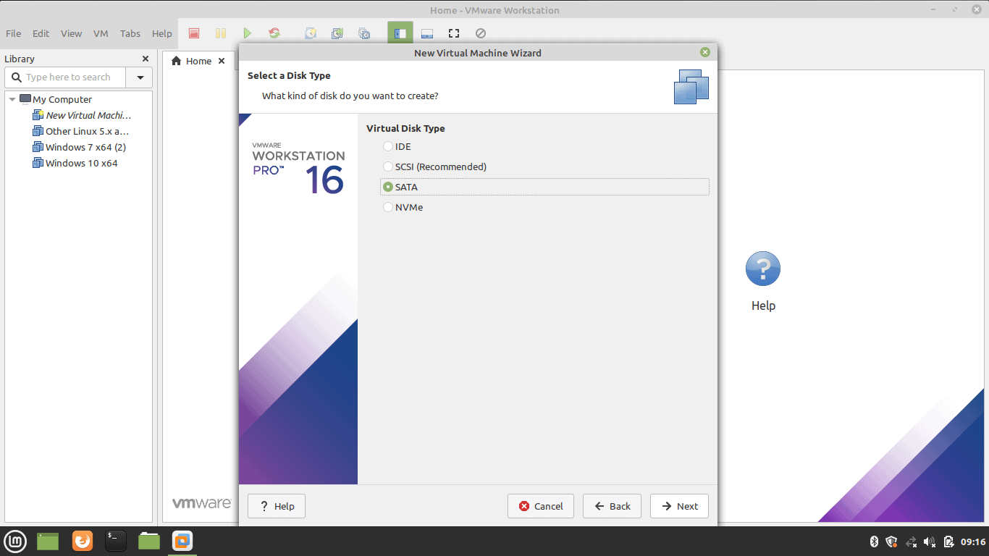

1. Select Virtual Disk

Select the Virtual Disk if we have or create one.  
  
  
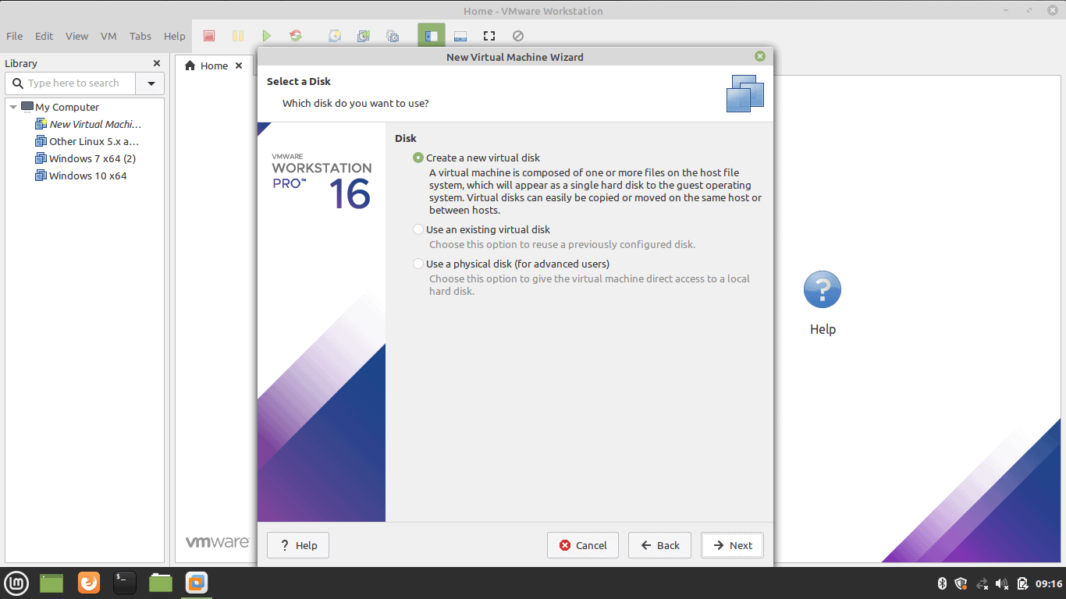

1. Select Disk Capacity

Select the disk size. Selecting a single disk will increase the performance. However, selecting a split disk will help in the disk transfer scenario.  
  
  
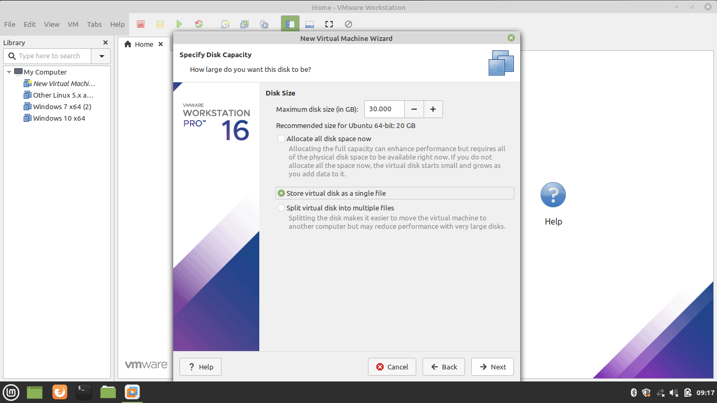

1. Specify Virtual Disk File

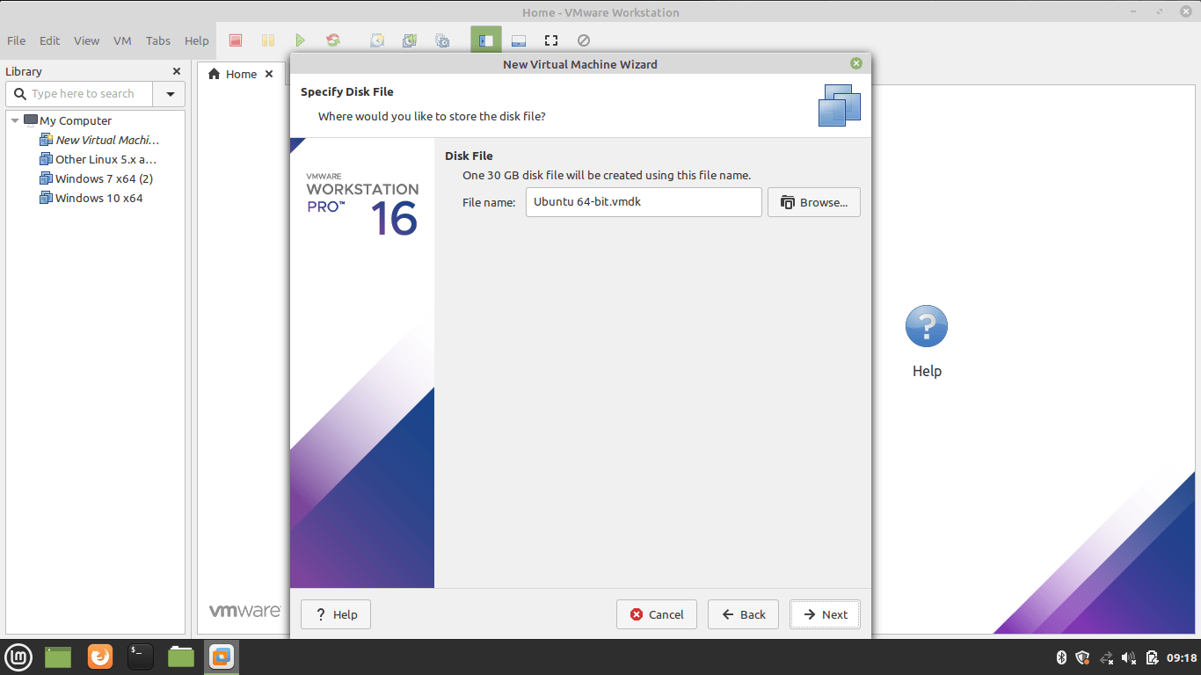

1. Create Virtual Machine

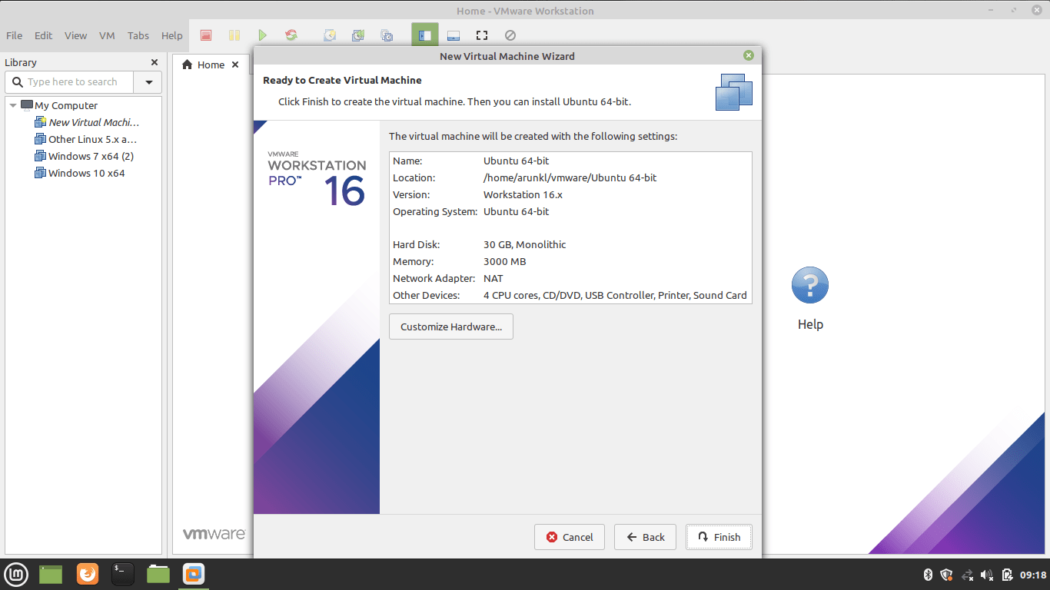

1. Supply Ubuntu ISO Image to Virtual Machine

Download Ubuntu image. Edit the CD/DVD settings and import the downloaded Ubuntu image.  
  
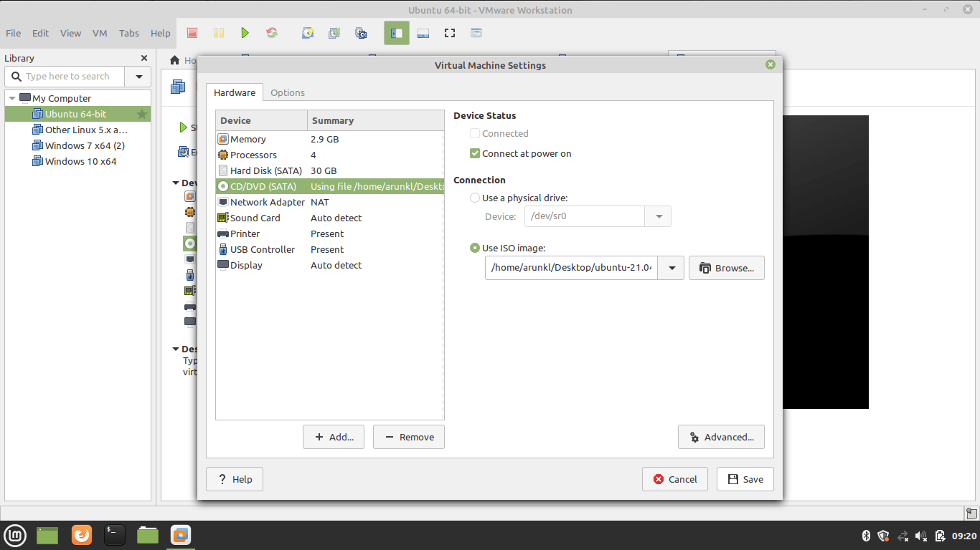

1. Install Ubuntu Linux on VMWare Workstation

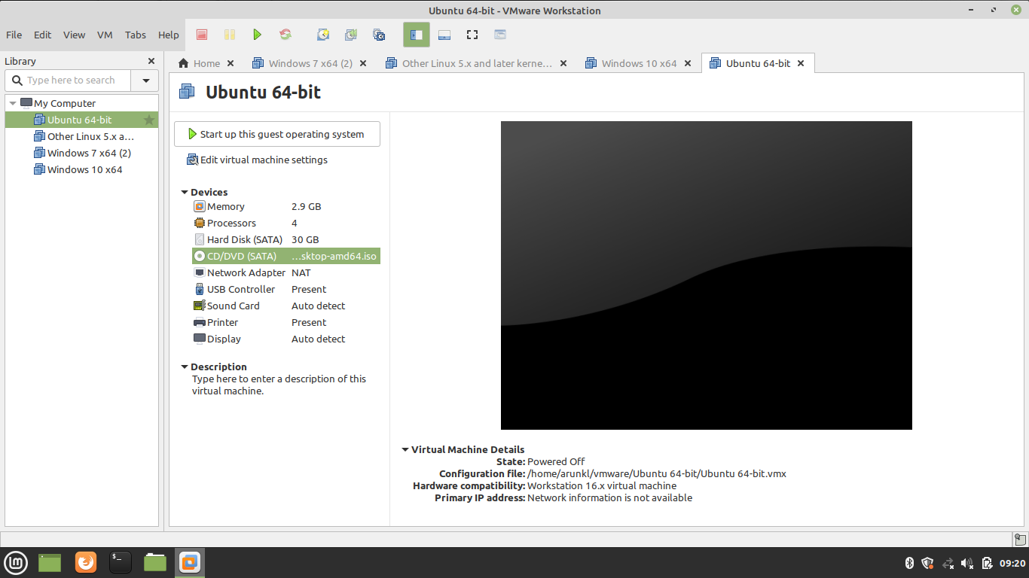

1. Power On the Virtual Machine

Press the Play button to power on the Virtual Machine.  
  
  
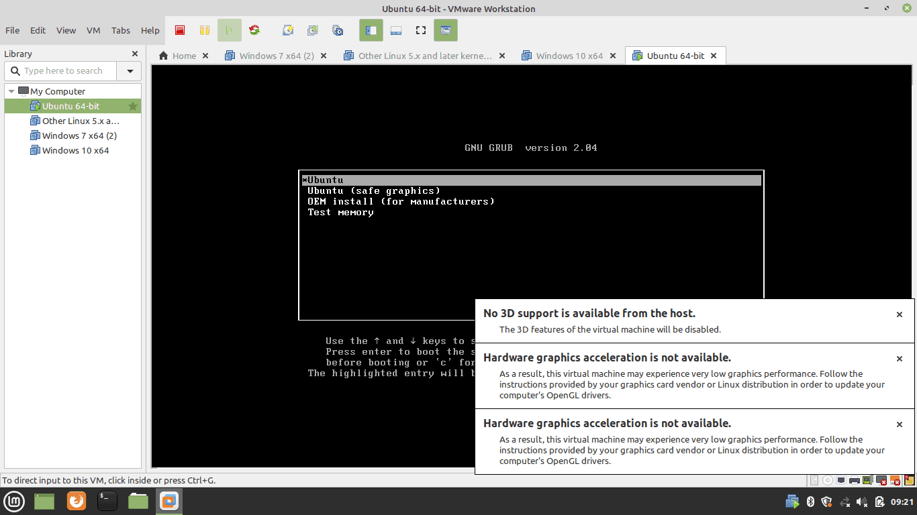

1. Welcome Ubuntu Virtual Machine

After powering on the Virtual machine, we will be treated with a welcome screen on which we will see two options: Try Ubuntu and Install Ubuntu. Select Try Ubuntu if we want to run Ubuntu in live mode. Select Install to continue the installation process.  
  
  
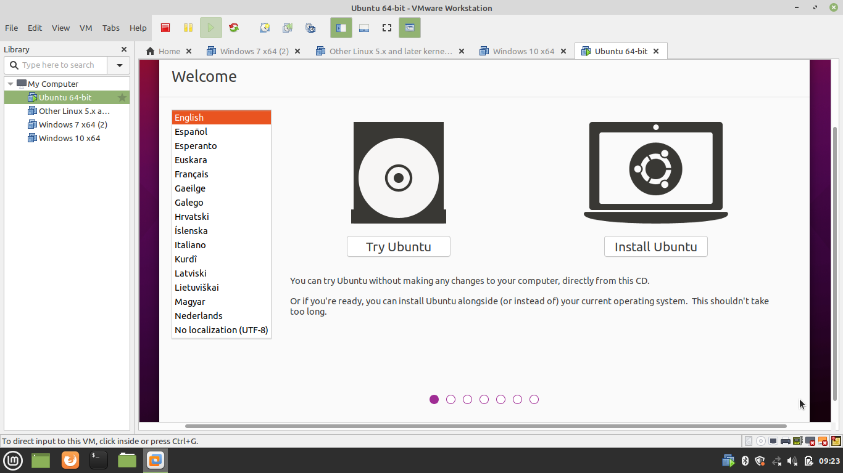

1. Select Keyboard Lawet

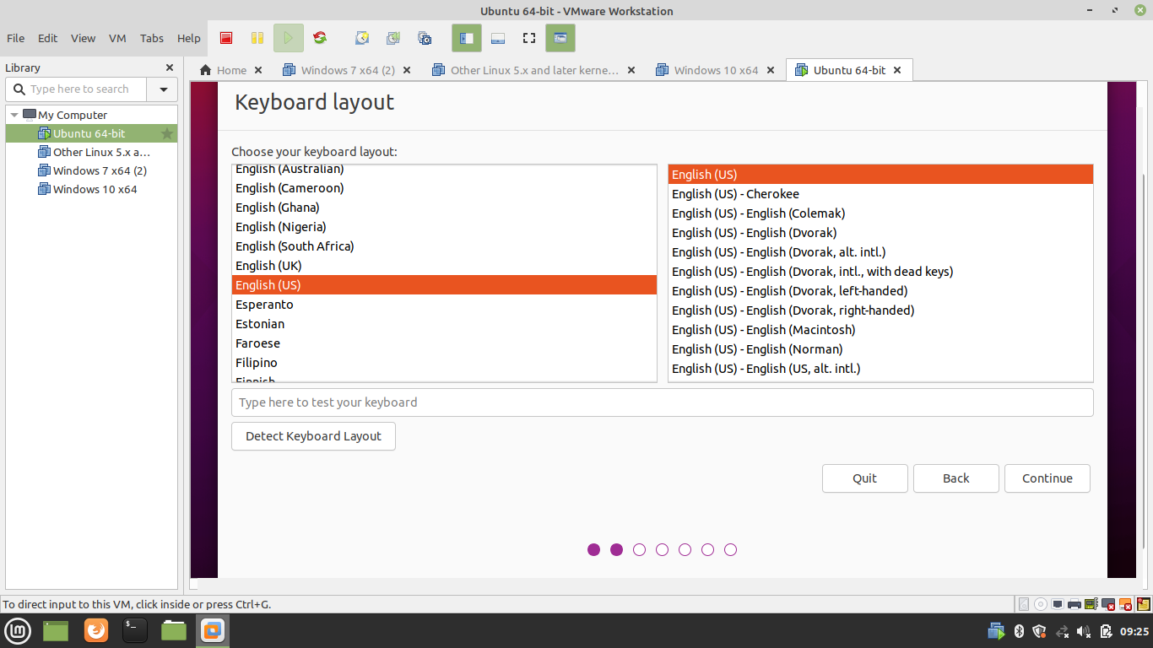

1. Software Update and Package Selection in Virtual Machine

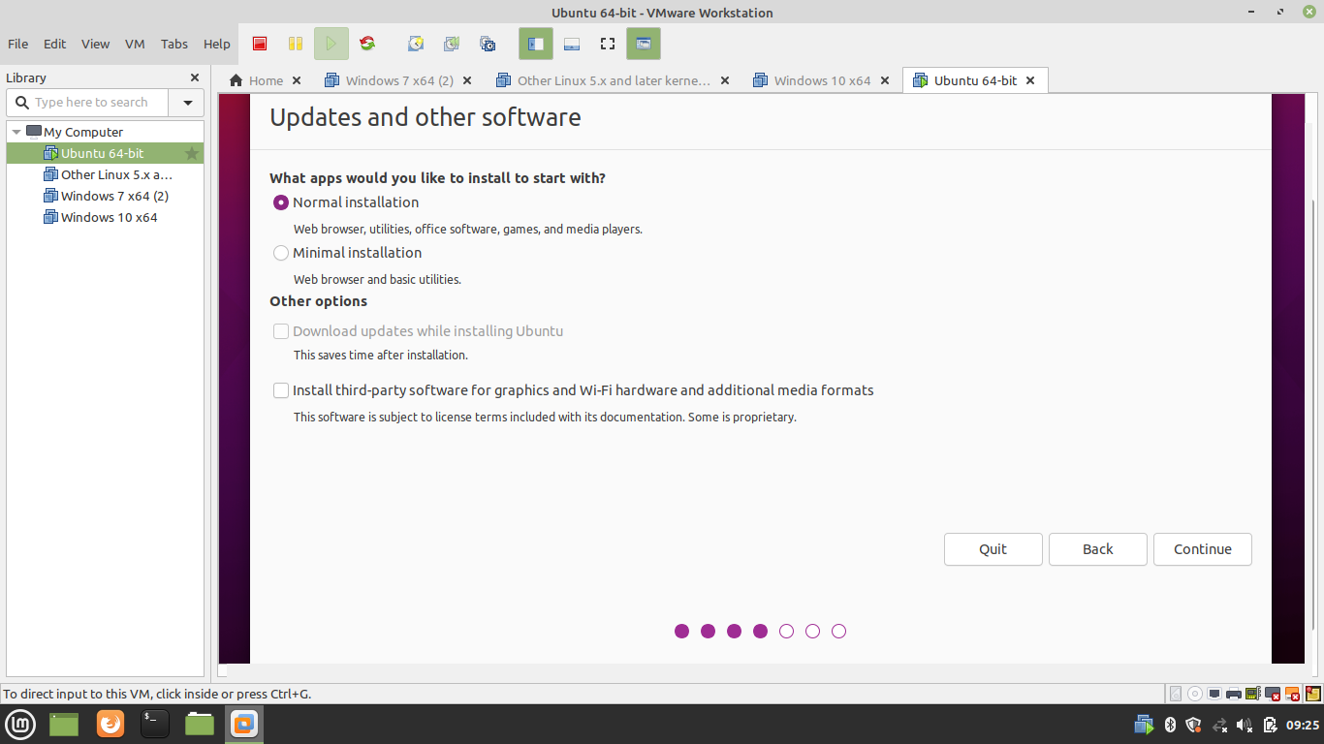

1. Partition the Disk

Select Erase the Disk for auto partition. Or Select the Advance option to create the custom partition.  
  
  
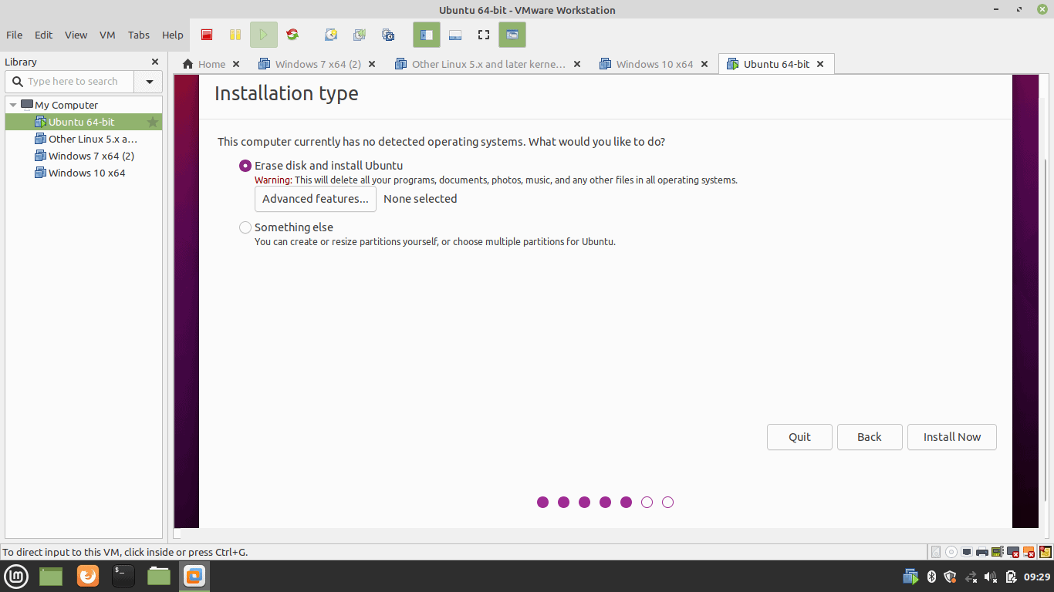

1. Write Changes to Disk

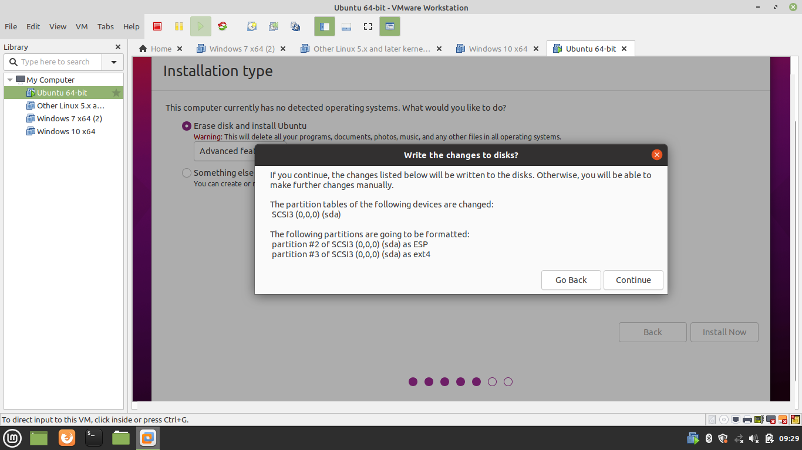

1. Select Time Zone

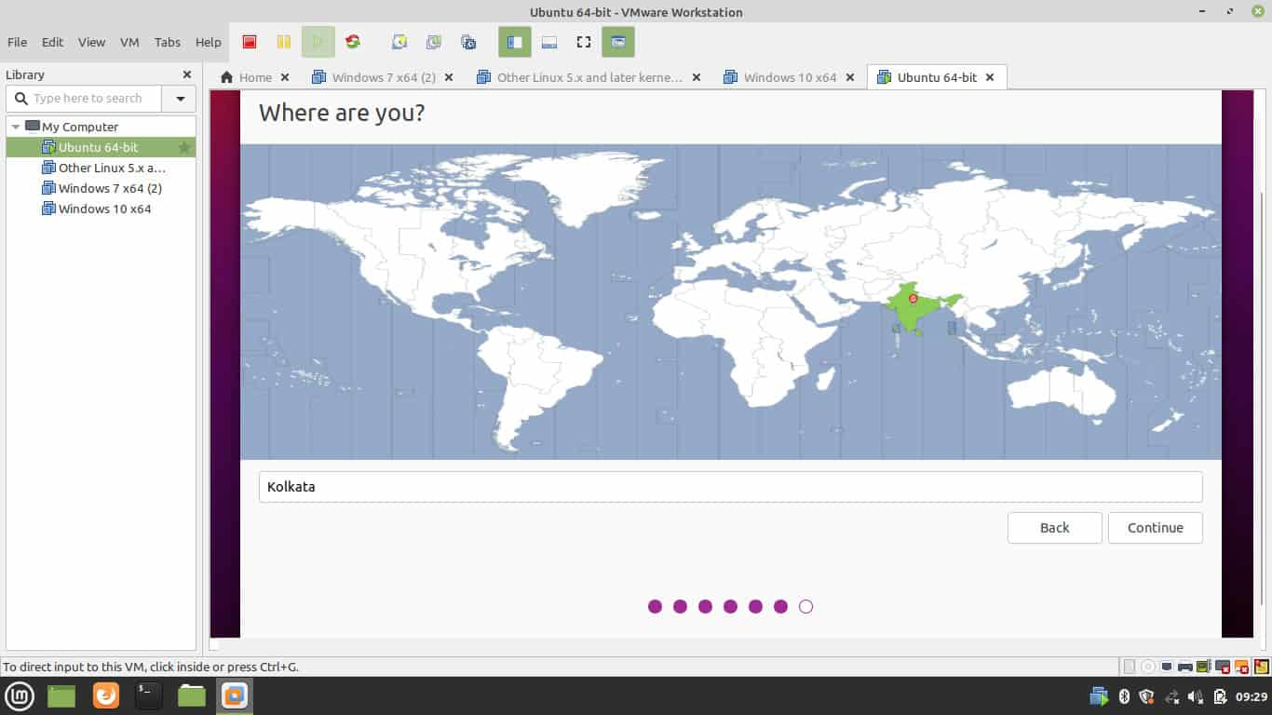

1. Create an Admin Account

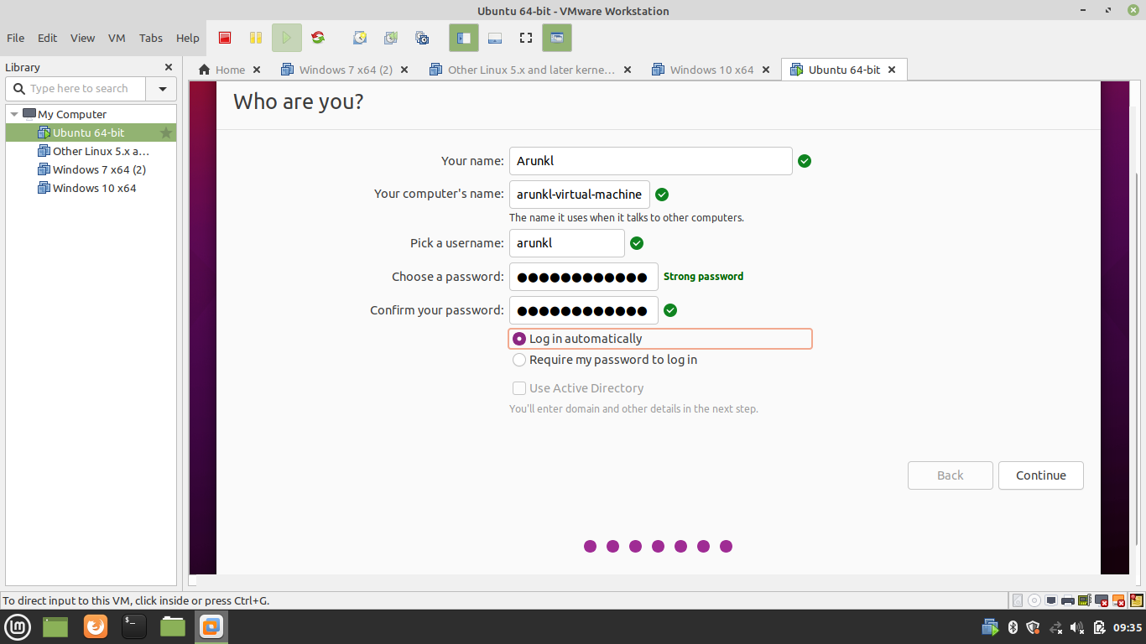

1. Installation of Ubuntu in Progress

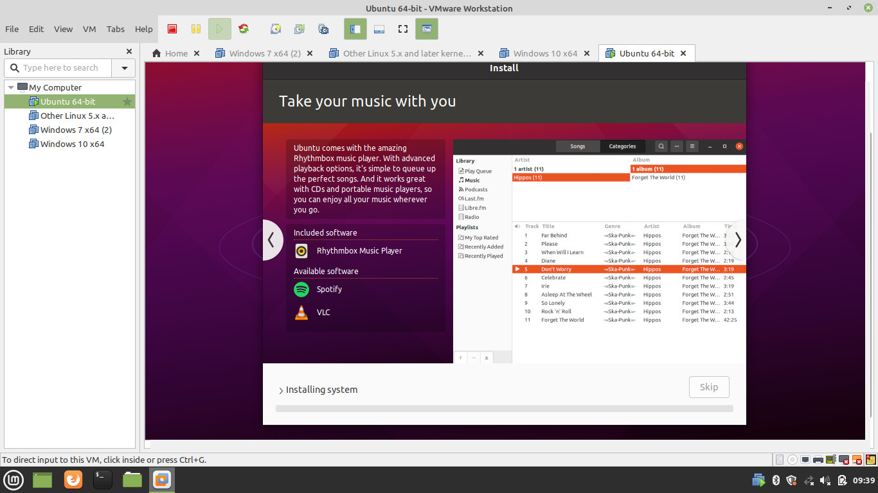

1. Reboot Virtual Machine

Reboot the machine after installation.  
  
  
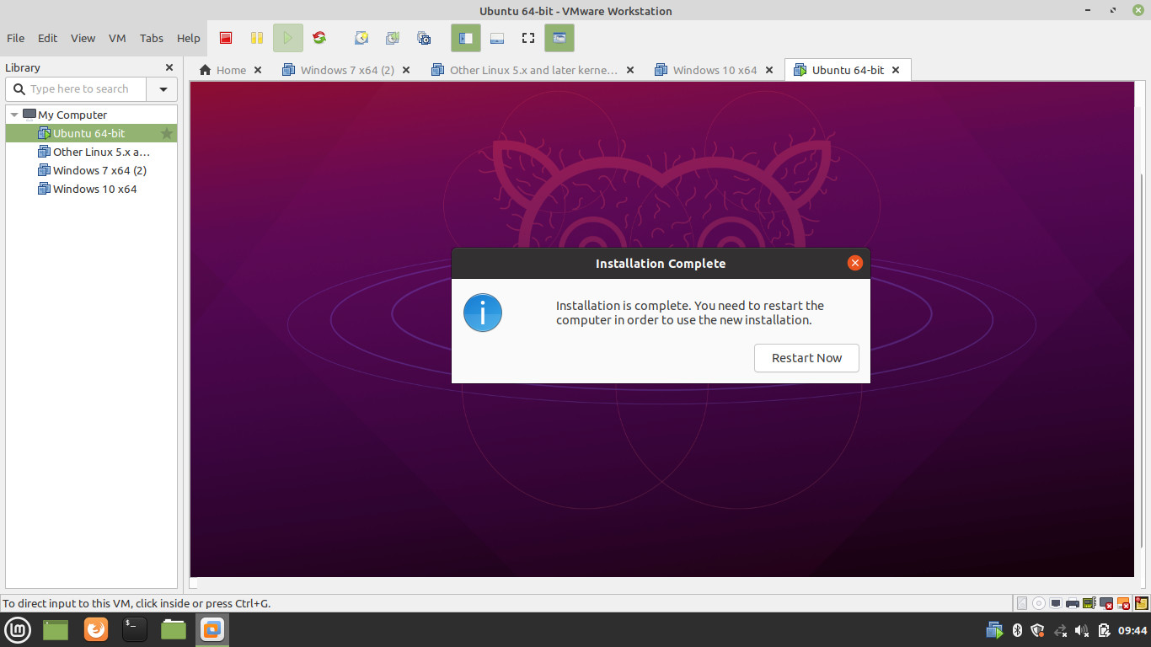

1. Remove the installation media

Remove the installation media before reboot.  
  
  
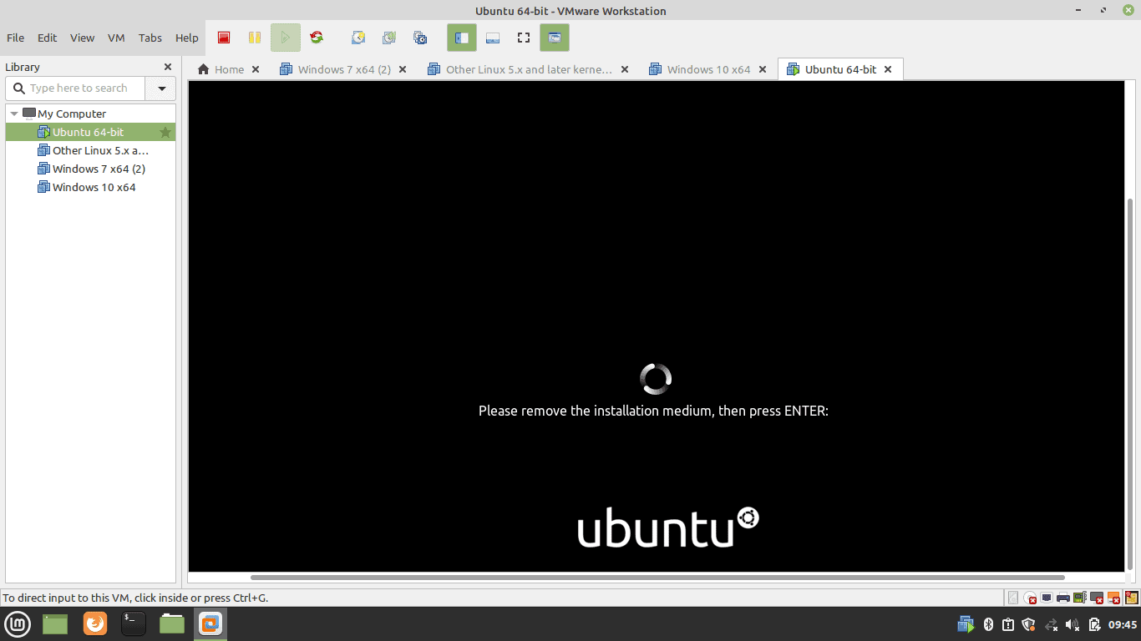

1. Boot Ubuntu

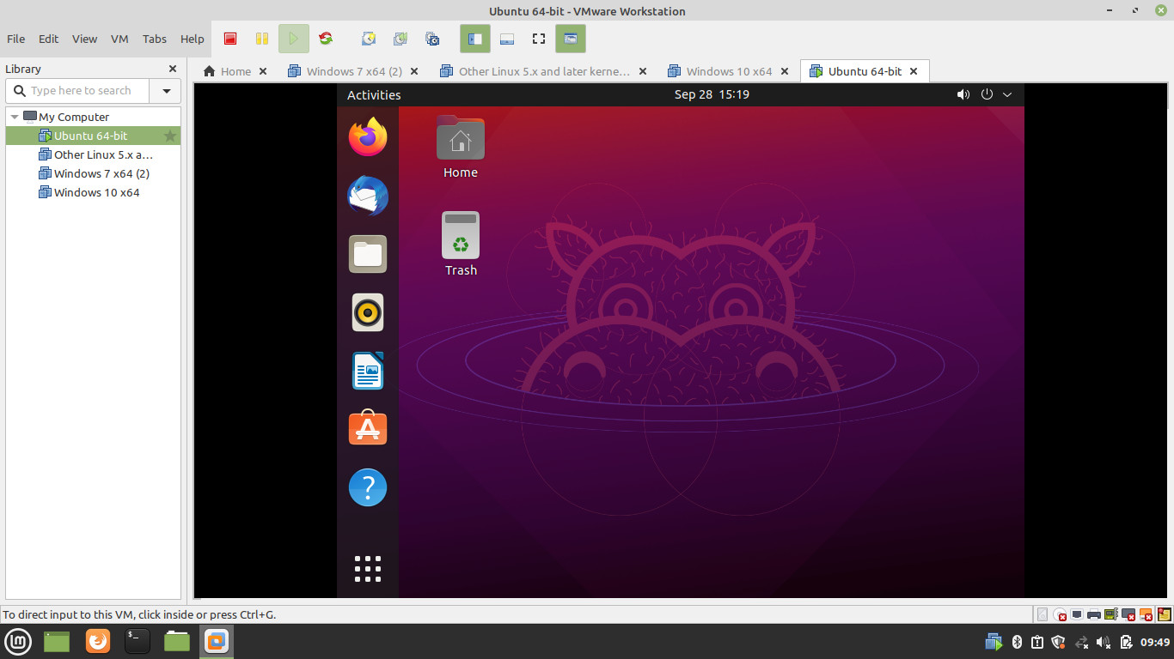

Basic 25 Unix shell commands:

1. pwd — When we first open the terminal, we are in the home directory of our user. To know which directory we are in, we can use the “pwd” command. It gives us the absolute path, which means the path that starts from the root. The root is the base of the Linux file system. It is denoted by a forward slash( / ). The user directory is usually something like "/home/username".

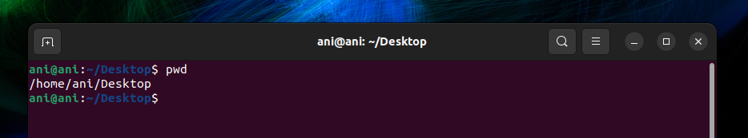

2. ls — Use the "ls" command to know what files are in the directory we are in. We can see all the hidden files by using the command “ls -a”.

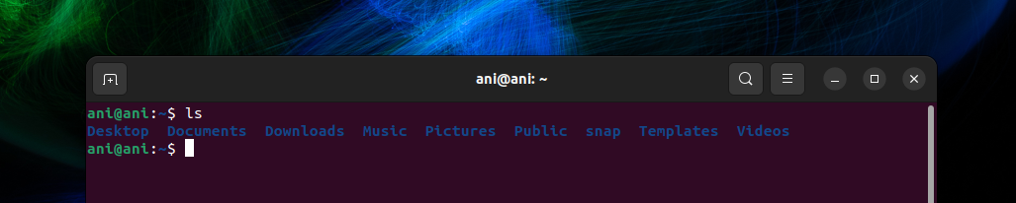

3. cd — Use the "cd" command to go to a directory. For example, if we are in the home folder, and we want to go to the downloads folder, then we can type in “cd Downloads”. Remember, this command is case sensitive, and we have to type in the name of the folder exactly as it is.

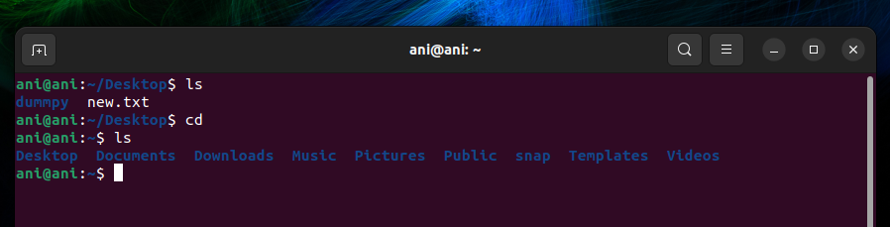

4. mkdir — Use the mkdir command when we need to create a folder or a directory. For example, if we want to make a directory called “DIY”, then we can type “mkdir DIY”. Remember, as told before, if we want to create a directory named “DIY Hacking”, then we can type “mkdir DIY\ Hacking”.

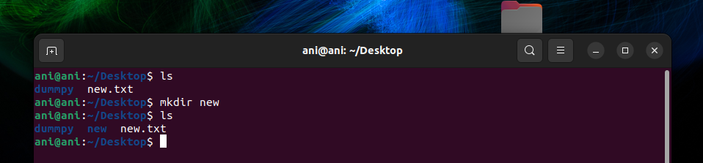

5. rmdir —Use rmdir to delete a directory. But rmdir can only be used to delete an empty directory. To delete a directory containing files, use rm.

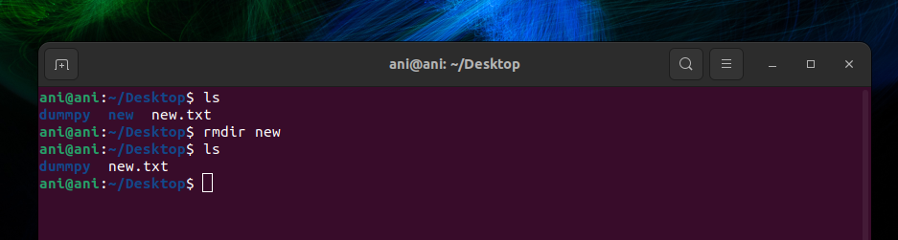

6. touch — The touch command is used to create a file. It can be anything, from an empty txt file to an empty zip file. For example, “touch new.txt”.

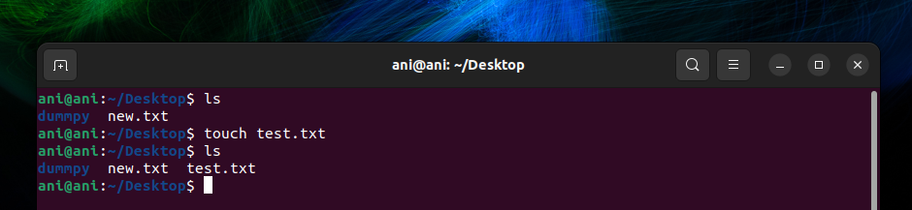

7. rm - Use the rm command to delete files and directories.  Use "rm -r" to delete just the directory. It deletes both the folder and the files it contains when using only the rm command.

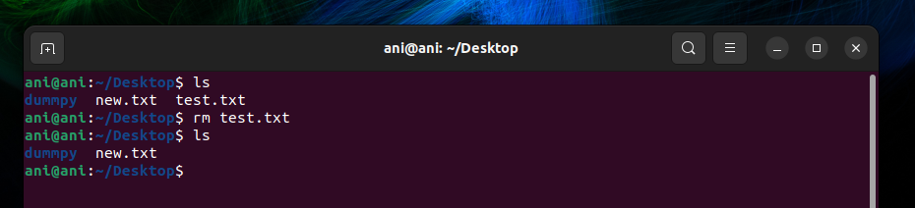

8. man— To know more about a command and how to use it, use the man command. It shows the manual pages of the command. For example, “man rm” shows the manual pages of the rm command.

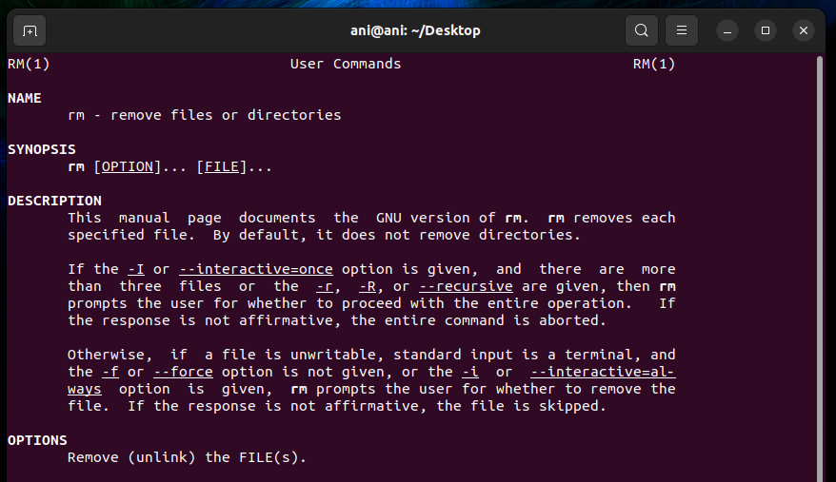

9. cp — Use the cp command to copy files through the command line. It takes two arguments: The first is the location of the file to be copied, the second is where to copy.

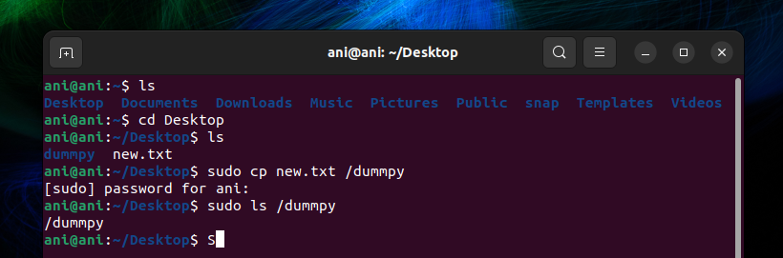

10. mv — Use the mv command to move files through the command line. We can also use the mv command to rename a file. For example, if we want to rename the file “text” to “new”, we can use “mv text new”.

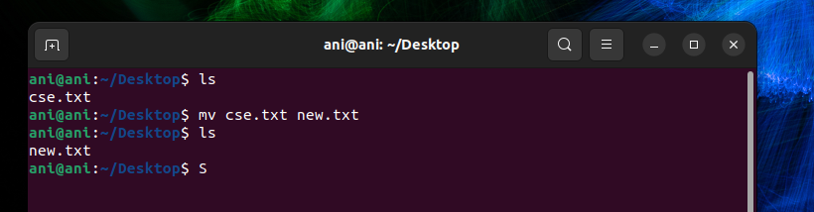

11. locate — The locate command is used to locate a file in a Linux system, just like the search command in Windows. This command is useful when we don't know where a file is saved or the actual name of the file. Using the -i argument with the command helps to ignore the case (it doesn't matter if it is uppercase or lowercase). So, if we want a file that has the word “hello”, it gives the list of all the files in our Linux system containing the word "hello" when we type in “locate -i hello”

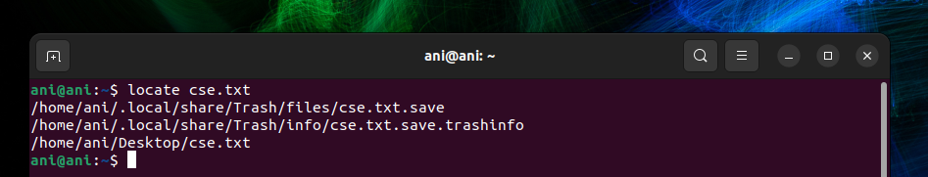

12. echo — The "echo" command helps us move some data, usually text into a file.

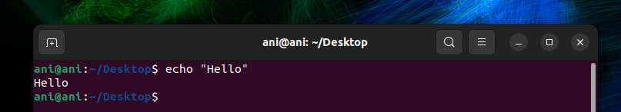

13. cat — Use the cat command to display the contents of a file. It is usually used to easily view programs.

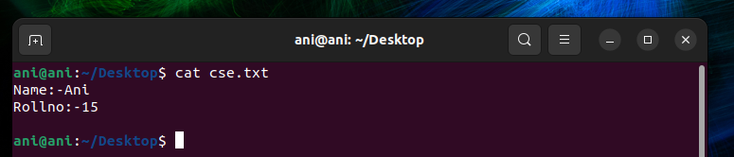

14. nano — nano is already installed text editors in the Linux command line. The nano command is a good text editor that denotes keywords with color and can recognize most languages.

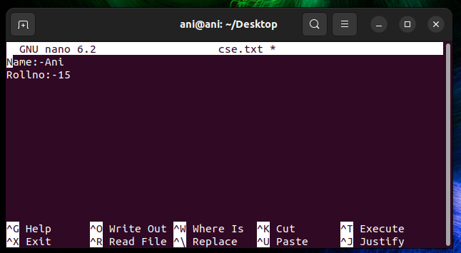

15. and (&&): — and“and” command in linux which is used to combine two more commands

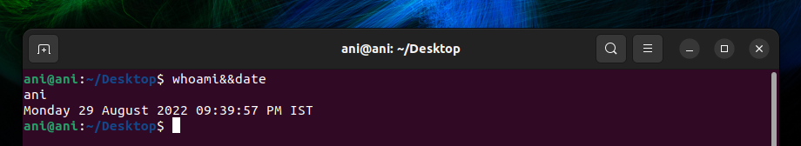

16. df — Use the df command to see the available disk space in each of the partitions in our system. We can just type in df in the command line and we can see each mounted partition and their used/available space in % and in KBs. If we want it shown in megabytes, we can use the command “df -m”.

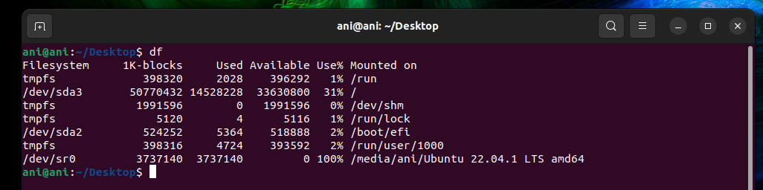

17. du — Use du to know the disk usage of a file in our system. If we want to know the disk usage for a particular folder or file in Linux, we can type in the command df and the name of the folder or file. For example, if we want to know the disk space used by the documents folder in Linux, we can use the command “du Documents”. We can also use the command “ls -lah” to view the file sizes of all the files in a folder.

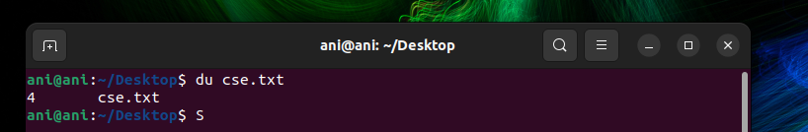

18. tty – Use tty to show the current display path name.

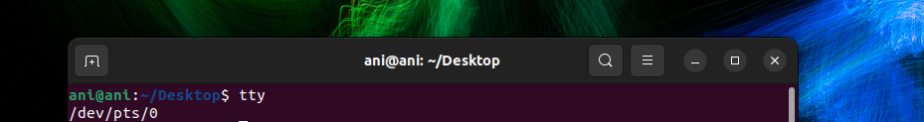

19.date: — Using date command we can see the system date and time in the given format.

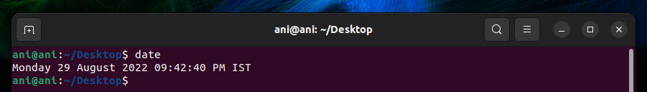

20.Seq – Using seq command in linux we can print a sequence in terminal using initial and final values given by us

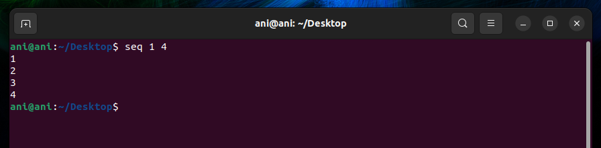

21. uname — Use uname to show the information about the system our Linux distro is running. Using the command “uname -a” prints most of the information about the system. This prints the kernel release date, version, processor type, etc.

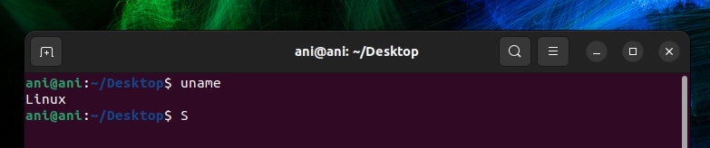

22. Whoami: — using “whoami” command in linux we can find the name of current user.

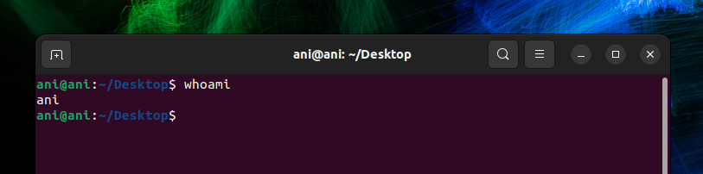

23. Basic calculator- Using “bc” command in linux terminal we can access basic calculator

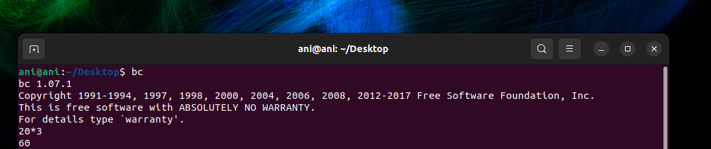

24. hostname — Using hostname gives us our name in our host or network. It displays our hostname and IP address. Typing “hostname” gives the output. Typing in “hostname -I” gives we our IP address in our network.

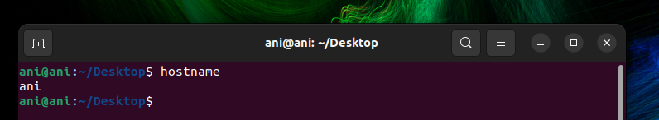

25. ping — Use ping to check our connection to a server. when we type in, for example, “ping google.com”, it checks if it can connect to the server and come back. It measures this round-trip time and gives we the details about it. The use of this command for simple users like us is to check our internet connection. If it pings the Google server (in this case), we can confirm that our internet connection is active.

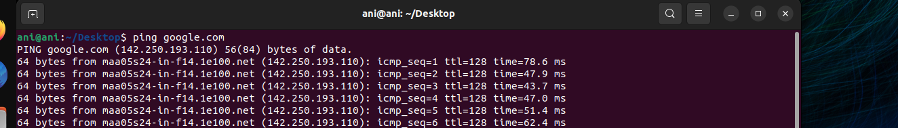

Result:

We have performed 25 unix shell commands in ubuntu terminal and recorded their output